PROJECT REPORT FOR BACHELOR OF SCIENCE IN COMPUTER SCIENCE AND INFORMATION TECHNOLOGY

**OCD TEST QUIZ**



**ANKIT RIMAL [5-2-1113-39-2022]**

**DEVRAJ KHATIWADA [5-2-1113-46-2022]**

**PRANJAL KHAREL [5-2-1113-52-2022]**

**RAVI SHAH [5-2-1113-61-2022]**

**SAMRIDDHI COLLEGE**

**DEPARTMENT OF SCIENCE AND TECHNOLOGY**

**APRIL 25, 2023**

PROJECT REPORT FOR BACHELOR OF SCIENCE IN COMPUTER SCIENCE AND INFORMATION TECHNOLOGY

**OCD TEST QUIZ**

**SUPERVISED BY Er. MOHAN BHANDARI**

**FACULTY, SAMRIDDHI COLLEGE**

A REPORT SUBMITTED

FOR

FIRST SEMESTER C-PROGRAMMING PROJECT

**ANKIT RIMAL [5-2-1113-39-2022]**

**DEVRAJ KHATIWADA [5-2-1113-46-2022]**

**PRANJAL KHAREL [5-2-1113-52-2022]**

**RAVI SHAH [5-2-1113-61-2022]**

**SAMRIDDHI COLLEGE**

**DEPARTMENT OF SCIENCE AND TECHNOLOGY**

**FEBRUARY, 2023**

**DECLARATION**

I hereby declare that this project entitled **OCD TEST QUIZ** is based on my original research work. Related works on this project by other researchers have been duly acknowledged. I owe all the liabilities relating to the accuracy and authenticity of the data and any other information included hereunder.

Ankit Rimal

Devraj Khatiwada

Pranjal Kharel

Ravi Shah

**Date: 2021-04-25**

**RECOMMENDATION**

This is to certify that this project entitled **OCD TEST QUIZ** prepared and submitted by **Ankit Rimal, Devraj Khatiwada, Pranjal Kharel, Ravi Shah** for first semester C-Programming Project of Bachelor of Computer Science and Information Technology awarded by Tribhuvan University, has been completed under my supervision.

**ER. MOHAN BHANDARI**

Faculty, Samriddhi College

Date: February 2023

**ACKNOWLEDGEMENT**

First of all, the party that we would like to thank is Samriddhi College, for providing this excellent opportunity to participate in this project. Also, we would also like to thank the faculty for utilizing this minor project model to consolidate our knowledge on C-Programming and many concepts that are associated with it. We would also like to extend our thanks to our faculty members of C-Programming Mr. Mohan Bhandari and Mr. Bikal Adhikari for sharing their invaluable knowledge and providing guidance on this particular topic. Furthermore, we would also like to thank our principal Mr. Sandeep Shrestha, along with Arpan Maskey sir and Lok Nath Regmi sir for providing us with the environment and facility so that we could complete the project on time without any time constraints and any pressures. Lastly, we would also like to thank our seniors and friends who have contributed their time to our project by helping us proof read, debug and guide us along the way. This endeavor wouldn’t be successful without the involvement of these parties and although not named we would also like to thank anyone remotely associated with this project and we would like them to know that their helps and advice have been invaluable in this endeavor.

**ABSTRACT**

The "OCD Test Quiz" is a cutting-edge software program written in the C programming language with the goal of facilitating OCD self-evaluation. The quiz comprises of ten intelligently prepared questions with various response possibilities that use file handling techniques for effective data management. The project offers a user-friendly interface that displays questions one at a time and collects responses using simple input techniques.

The goal of this study project is to give people a simple technique to determine whether they could have OCD. Through response-based weight modifications, adaptive scoring improves assessment accuracy. Users can comprehend the chance of OCD symptoms being present by looking at the total score that is produced by the quiz's computation.

The system creates a thorough report and saves user input and calculated scores in a file with a special name. According to accepted reporting guidelines, the report includes the user's name, the date of the test, and the completion time. Score interpretations are divided into levels to provide insight into the potential severity of the symptoms.

It is crucial to understand that this test is only meant to act as a first indicator and is not meant to be a diagnostic tool. Licensed healthcare professionals should be consulted for a formal diagnosis and treatment. In order to emphasize individualized care and qualified mental health guidance, the project's conclusion offers customized recommendations depending on the test results.

In conclusion, the "OCD Test Quiz" shows how C programming and file handling methods may be combined to provide a user-friendly and educational tool for a preliminary self-assessment of OCD symptoms. The project helps to raise awareness of mental health issues and encourages people to get the help they need if they need it.

Keyword: *OCD test, OCD quiz, OCD test quiz, Mental Health and OCD checkup*

**TABLE OF CONTENT**

1. INTRODUCTION 9

1.1 INTRODUCTION 9

1.2 PROBLEM STATEMENT 10

1.3 OBJECTIVES 10

1.4 SCOPE 10

1.5 OVERVIEW OF REPORT 10

2. BACKGROUND STUDY & LITERATURE REVIEW 11

2.1 BACKGROUND STUDY 11

2.2 LITERATURE REVIEW 11

3. SYSTEM ANALYSIS AND DESIGN 13

3.1 SYSTEM ANALYSIS 13

3.1.1 REQUIREMENTS GATHERING 13

3.1.2 USER EXPECTATIONS 13

3.1.3 FEASIBILITY ANALYSIS 13

3.2 SYSTEM DESIGN 14

3.2.1 ALGORITHM 14

3.2.2 FLOWCHART 14

4. RESULT AND DISCUSSION 14

4.1 RESULT 14

4.1.1 SAMPLE TEST RESULTS 17

4.1.2 TOTAL SCORE CALCULATION 18

4.1.3 ASSESSMENT CATEGORY 19

4.2 DISCUSSION 19

4.2.1 EFFECTIVENESS OF ADAPTIVE SCORING 19

4.2.2 ACCURACY OF TEST RESULTS 19

4.2.3 USER FRIENDLY INTERFACE 19

5. LIMITATIONS 20

6. FUTURE WORK 20

7. RECOMMENDATION AND CONCLUSION 21

7.1 RECOMMENDATION 21

7.2 CONCLUSION 22

8. REFERENCE 23

# INTRODUCTION

## INTRODUCTION

Obsessive compulsive disorder (OCD) is a type of mental illness that usually occurs at a young age. Think of your brain as a beneficial alarm system that tries to keep you safe, but sometimes it's a bit hypersensitive and overreacts to certain thoughts or anxieties.

Although everyone worries or feels the need to check things occasionally, the symptoms associated with OCD are severe and persistent. These symptoms can cause anxiety and lead to behavior that interferes with daily activities. People with OCD may feel the urge to repeatedly check things or perform routines for more than an hour each day to achieve temporary anxiety relief. If OCD symptoms are not treated, these behaviors can interfere with work, school, and personal relationships, and can cause feelings of anxiety. Symptoms of OCD tend to appear in childhood, around age 10, or in young adulthood, around age 20 to 21, and often appear earlier in boys than in girls. Most people are diagnosed with OCD by the time they reach young adulthood. [1]

As our first semester C programming project, we developed the 'OCD Test Quiz' project. It is made for assessing and evaluating an individual's obsessive and compulsive tendencies using a set of ten questions. Our aim of this project is to provide people with a self-assessment tool that gives insight into their OCD related thoughts and behaviors.

It is important to emphasize that the ‘OCD test’ is purely for its own purposes and should not be considered a diagnosis. It should never take the place of an evaluation by a healthcare professional.

For this project, we created C software that asks users questions about OCD symptoms and habits. Based on their answers, the program calculates a score that predicts the likelihood of developing OCD.

Our intention is to use the ‘OCD Test’ to raise awareness and encourage individuals to seek help if they suffer from OCD or other mental health issues.

## PROBLEM STATEMENT

According to the World Health Organization, "In 2019, 1 in every 8 people, or 970 million people around the world were living with a mental disorder." [2]

When 1 out of every 8 people is being suffered from different types of mental disorder we must be cautious and take care of our mental health. OCD is slowly becoming the common in today’s young children or some adults.

As a result, we aim to develop simple and easily accessible software to help you to detect if you have OCD symptoms or not. Taking the OCD test is simple as it provides a set of questions and five different answers to those questions. Anyone who understands English can take the test. It is helpful or even more beneficial if you can notice and understand any symptoms of OCD so that you can talk to mental health specialists, be more proactive about the condition, and take care of your mental health.

## OBJECTIVES

The objective of our project “OCD Test Quiz” are as follows:

1. To create a C program to perform a mental health assessment related to OCD.
2. To collect user responses through a series of questions.
3. To calculate a total score based on user responses and a weighted scoring mechanism.
4. To generate a report with username, date, time, and test results.
5. To provide appropriate recommendations based on the calculated score.
6. To utilize our knowledge in C-Programming to make something useful.

## SCOPE

1. Design of a user-friendly and interactive console-based question interface.
2. Using an adaptive scoring technique to change question weights in response to user responses.
3. Create a text file report to summarize user test results and recommendations.

## OVERVIEW OF REPORT

This project report covers the "OCD Test" project in detail. Research, literature review, system analysis, system design, results, discussion, limitations, recommendations, and conclusions are included.

# BACKGROUND STUDY & LITERATURE REVIEW

## BACKGROUND STUDY

Our team decided to create the project “OCD Test Quiz” as OCD is a mental health condition that affects millions of people worldwide. It impacts the daily life of the people suffered from it. So, by creating OCD Test Quiz we want to make people aware about OCD, its symptoms and importance of early detection and intervention of OCD.

As the symptoms of OCD are obsessions and compulsions that interfere with normal activities. For example, symptoms may often prevent you from getting to work on time. Or you may have trouble getting ready for bed in a reasonable amount of time. [3]

Our project "OCD Test Quiz" attempts to give opportunity for people to facilitate self-assessment and improve mental health awareness by combining C Programming and mental health. People can use the quiz to know more about their behavior and thoughts and if they have symptoms of OCD or not, which can lead them to seek professional help if needed.

Our project provides essential insight into likely OCD symptoms. However, the quiz is not a diagnostic tool. Only licensed mental health professionals are able to accurately diagnose mental health problems. The quiz serves as an educational and supportive platform to raise awareness of OCD and encourage people to prioritize their mental health.

Due to above mentioned reasons our team decided to make OCD Test Quiz as our project using C-Programming and file handling in C-Programming.

## LITERATURE REVIEW

Mental health goes beyond major, life-debilitating problems, such as depression or OCD. We all have a mind! So we can benefit from a healthy mind. Like an itchy throat might signal the start of a cold, frequent problems might signal underlying mental health issues (e.g. feeling angry very often, or constantly being upset that you ‘should have known’ how to handle a situation.) And just like you’re better off in the long run addressing the cold before it really starts, it can be extremely beneficial to your wellbeing to work on improving your mental health. Most people still believe you only need to see a therapist if you have a serious mental health issue. But, ideally, one goes to the doctor to get regular checkups to find out whether anything needs a little help. Mental health should be thought of in the same way: checking in on how our mental space is doing is important even during times of calm. [4]

Obsessive-compulsive disorder (OCD) is a mental disorder in which people experience unwanted and repeated thoughts, feelings, images, or sensations (obsessions) and engage in behaviors or mental acts (compulsions) in response. Often a person with OCD carries out the compulsions to temporarily eliminate or reduce the impact of obsessions, and not performing those leads to cause distress. OCD varies in severity, but if left untreated, it can limit one's ability to function at work, school, or home. [5]

With the increased recognition of the prevalence and severity of obsessive- compulsive disorder (OCD), increased attention has been devoted to its assessment and treatment in recent years. Currently, several different methods are used to assess obsessive-compulsive symptoms, including diagnostic interviews, clinician administered inventories, self-report measures and parent-report measures. [6]

Self-report measures have several advantages in OCD assessment, as they can generally be completed quickly, independently, and administered to a number of individuals at once. They are useful as screening questionnaires and are often employed to identify potential research participants and candidates for treatment. In addition, people may feel more comfortable completing measures independently. This can guard against the under-reporting (or over reporting) of symptoms that is sometimes observed during a clinician-administered interview. However, there are some disadvantages. For example, an individual’s response style may affect his assessment of symptoms based on different interpretations of choices, such as “sometimes” or “often.” In addition some respondents may have difficulty understanding the format or wording of the questionnaire, while others may not use adequate care when completing the questionnaire. Finally, the broad and variable range of symptoms in OCD may result in an underestimate of a person’s impairment, because specific and/or idiosyncratic symptoms may not be included in the measures. [6]

# SYSTEM ANALYSIS AND DESIGN

## SYSTEM ANALYSIS

### REQUIREMENTS GATHERING

During our project’s requirements gathering phase, we identified the following key requirements for the "OCD Test Quiz" project:

1. Questions: Design a set of ten questions that are commonly related to the thoughts and behaviors that are related with OCD.
2. User Input: User or person taking the test are allowed to respond to each question by selecting an option from 0 to 4.
3. Scoring Mechanism: Implement an engaging scoring mechanism that adjusts the weight of each question based on user’s current and previous responses.
4. Report Card: Create a report card that contains user’s name, date, time, test results, and recommendations based on the score the user gets.

### USER EXPECTATIONS

User expectations for “OCD Test Quiz” includes following things:

1. An interactive and understandable interface that guides the user through the questions.
2. Each question should have clear instructions to ensure they understand the context and response options.
3. A scoring process that is accurate and reliable and delivers relevant results.
4. They receive personalized recommendations based on their exam scores.

### FEASIBILITY ANALYSIS

1. TECHNICAL FEASIBILITY

Our project is technically feasible because the code is written in C-Programming so it doesn’t require much investment except to learn concept of file handling in C-Programming which will not take much time.

1. OPERATIONAL FEASIBILITY

Our project is operationally feasible because it doesn’t require any investment to run normally it only requires that you have the file for the “OCD Test Quiz”.

1. ECONOMIC FEASIBILITY

OCD Test Quiz doesn’t cost anything so it is economically feasible to anyone who is interested in taking OCD test.

1. SCHEDULE FEASIBILITY

Our project only required a week and a few days to program so it doesn’t require much time investment hence it is feasible in any schedule.

## SYSTEM DESIGN

### ALGORITHM

### FLOWCHART

# RESULT AND DISCUSSION

## RESULT

The "OCD Test" project is successfully executed or completed, as it allows a person to take a self-assessment test related to obsessive-compulsive disorder (OCD). The program asks the person ten questions, gather his/her answers, calculates a total score based on an adaptive scoring mechanism, and creates a report card with the test results.

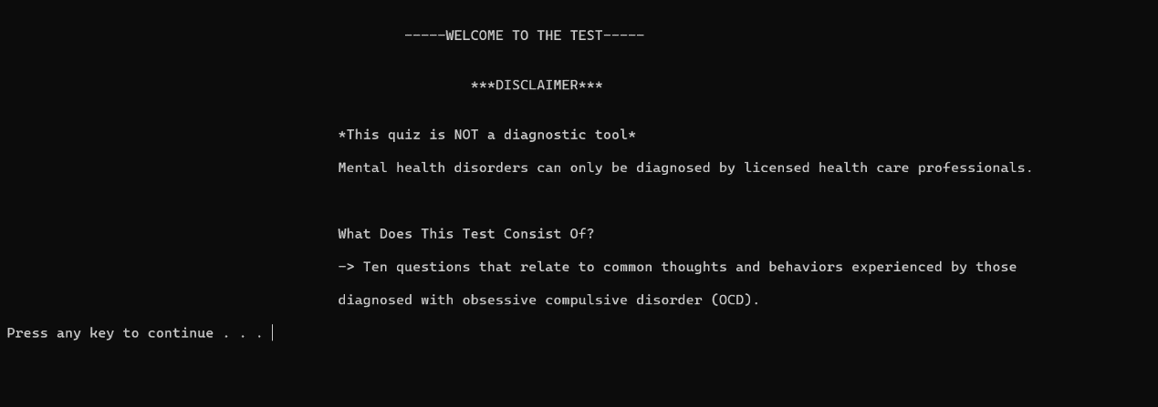The output of our program that displays the first interface when it is executed is shown in the image below:

The code we wrote while creating this project was successful and went smoothly. As you can see in above image that shows the first interface of our project in the terminal. Here you can see the disclaimer notice that tells people about how this quiz is not actually a diagnostic tool.

The second interface in shown in the image below: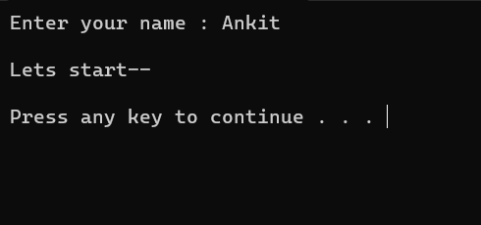

Here user or the person taking the test is required to enter their name as it is to be displayed in the report that is generated after the OCD test is completed by the person.

The third interface is shown in the image below:

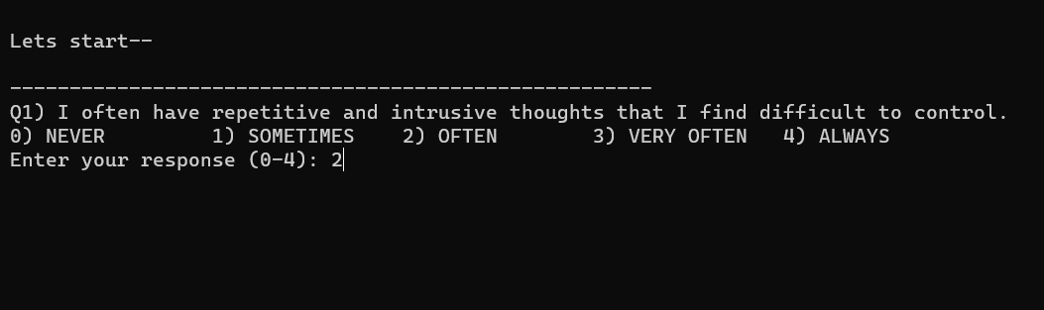

Here we can see the series of questions that were designed by our team is being asked to the person taking the OCD test. The person have 5 choices to choose and input the respective numbers (from 0 to 4) as the answer to the question. These answers of all ten questions are collected and then calculated to obtain the final score.

After answering all ten questions the final interface looks like this:

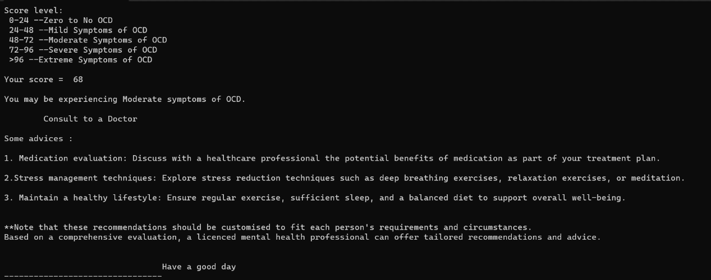

Here the person that took the test can see the score and what type of symptoms of OCD is he/she experiencing. Following this the actual report file is created for the person that took the OCD test in MS Word format.

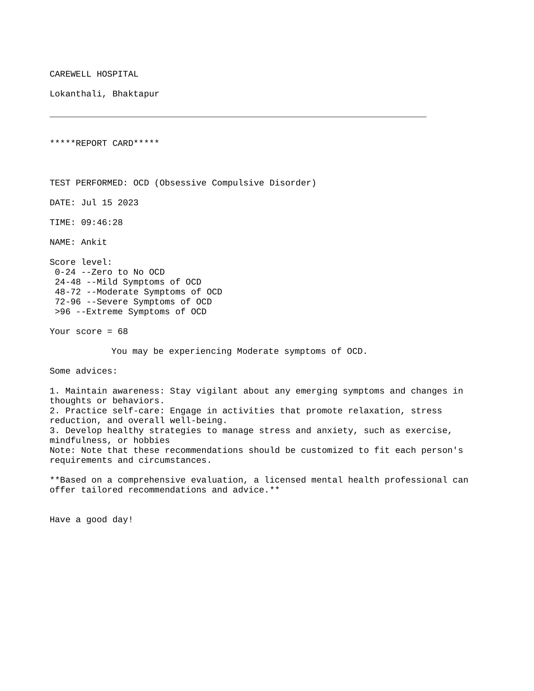The report sample that is created is shown in image below:

Here you can have a look at a simple report that is created when you finish the OCD Test Quiz. The above report file is created with help of implementation of concept of file handling in C-Programming. It generates the score based on the choices answered by the person to the series of questions that was designed for OCD test quiz.

### SAMPLE TEST RESULTS

As the info about actual output interface and the report generated after the test is already explained above. Here we can see the theoretical and clearer explanation of how the score system works for “OCD Test Quiz”.

Here are the sample responses and the corresponding scores for each question:

1. Question: "I often have repetitive and intrusive thoughts that I find difficult to control."

Adjusted Response: 4 (Always)

Weight: 2 (Adapted based on the response)

Score: 4 * 2 = 8

1. Question: "I feel a strong urge to perform certain actions or rituals repeatedly."

Adjusted Response: 3 (Often)

Weight: 3 (Adapted based on the response)

Score: 3 * 3 = 9

1. Question: "I have difficulties in making decisions due to excessive doubts and concerns."

Adjusted Response: 3 (Often)

Weight: 2 (Adapted based on the response)

Score: 3 * 2 = 6

1. Question: "I spend a lot of time checking or ensuring things are done correctly or perfectly."

Adjusted Response: 4 (Always)

Weight: 3 (Adapted based on the response)

Score: 4 * 3 = 12

1. Question: "I have a fear of contamination or getting sick and engage in excessive cleaning or washing."

Adjusted Response: 3 (Often)

Weight: 3 (Adapted based on the response)

Score: 3 * 3 = 9

1. Question: "I experience distress when things are not arranged symmetrically or in a specific order."

Adjusted Response: 2 (Often)

Weight: 2 (Adapted based on the response)

Score: 2 * 2 = 4

1. Question: "I find it hard to discard or throw away items that may seem useless or have no value."

Adjusted Response: 1 (Never)

Weight: 2 (Adapted based on the response)

Score: 1 * 2 = 2

1. Question: "I feel a need to confess or seek reassurance excessively about my thoughts or actions."

Adjusted Response: 2 (Often)

Weight: 3 (Adapted based on the response)

Score: 2 * 3 = 6

1. Question: "I have difficulties completing tasks due to repeating or redoing them multiple times."

Adjusted Response: 3 (Often)

Weight: 2 (Adapted based on the response)

Score: 3 * 2 = 6

1. Question: "I experience intrusive, unwanted thoughts or mental images that go against my values."

Adjusted Response: 2 (Often)

Weight: 2 (Adapted based on the response)

Score: 2 * 2 = 4

### TOTAL SCORE CALCULATION

Now, let's calculate the total score:

Total Score = 8 + 9 + 6 + 12 + 9 + 4 + 2 + 6 + 6 + 4

Total Score = 68

The total score is calculated by adding every question’s score. The score in every question is determined by the answer choices made by the person taking the OCD test and the weight that is adapted based on the response of that person while taking the test.

### ASSESSMENT CATEGORY

Based on the total score range, we categorize the test results into different assessment categories:

* Total Score 0-24: Zero to No OCD
* Total Score 24-48: Mild Symptoms of OCD
* Total Score 48-72: Moderate Symptoms of OCD
* Total Score 72-96: Severe Symptoms of OCD
* Total Score > 96: Extreme Symptoms of OCD

## DISCUSSION

The results of this project provide valuable information about the possibility of the person taking the OCD test will have obsessive-compulsive disorder. The adaptive scoring technique ensures that the test takes into account the user's response pattern and dynamically adjusts question weights, making the test more personalized and accurate.

### EFFECTIVENESS OF ADAPTIVE SCORING

The adaptive scoring mechanism proved effective in capturing changes in user responses, which significantly affected the resulting score. By assigning more weight to these questions with different choices, the test reflects a more delicate assessment of OCD related thoughts and behaviors.

### ACCURACY OF TEST RESULTS

OCD Test Quiz should be used only as self-assessment tool. It is important to know that these test results are not replacements for diagnoses done by licensed healthcare providers. However, the test serves as a useful indicator for users to be aware of potential OCD symptoms and consider seeking professional evaluation if necessary.

### USER FRIENDLY INTERFACE

The user interface of the “OCD Test Quiz” project was designed to be simple and easy to navigate. Users can navigate the questions smoothly, and clear instructions for each question help ensure accurate answers.

# LIMITATIONS

The "OCD Test" project has some limitations that should be acknowledged:

* **Self-Reporting Bias:** The accuracy of test results depends on honest and accurate self-reporting by users, which may be influenced by subjective perception.
* **Simplified assessment:** The "OCD test" is a simplified self-assessment tool and does not cover all aspects of a comprehensive clinical assessment.

# FUTURE WORK

To enhance the "OCD Test" project, several additional improvements can be considered:

1. **User Interface Enhancements:**

Implement a more user-friendly and interactive interface, possibly using graphical elements or color-coded responses. Provide clear instructions and explanations for each question to ensure users understand the context.

1. **Extended Question Set:**

Expand the question set to cover a wider range of OCD-related symptoms and behaviors. Collaborate with mental health professionals to develop an extensive and reliable set of questions.

1. **Result Analysis:**

Develop an algorithm to analyze the total score and provide a detailed breakdown of the user's responses to different question categories. Present the results in a visually appealing manner, such as charts or graphs.

1. **Multi-platform Support:**

Adapt the program to work on different operating systems (Windows, macOS, Linux) by handling platform-specific commands for clearing the screen.

1. **Localization:**

Allow the program to support multiple languages to make it accessible to a broader audience.

# RECOMMENDATION AND CONCLUSION

## RECOMMENDATION

We displayed our project to our friends, classmates, and teachers once we finished it. Many of them made remarks and suggestions on how to improve this self-assessment tool. Some of them are mentioned below. Our team had high expectations for how we would improve on what we had built, however owing to resource constraints and C-Programming, we believe we did an amazing job as a team. The following are the things we couldn't add to our project and the ideas we received:

1. **Validation research:** To determine the reliability and validity of the "OCD test", we recommend conducting validation research with a larger and more diversified sample. Comparison of test results with clinical diagnoses made by certified health professionals will help determine the validity and sensitivity of the test.
2. **Integrating User Feedback:** Collecting feedback from test takers will provide useful information about their experience as well as the comprehensibility of the questions. By incorporating user comments, we will be able to fine-tune the questionnaire and overall improve the usability of the application.
3. **Consider Adding Questions:** Adding more relevant questions about OCD symptoms to the questionnaire can provide a more comprehensive assessment. A careful selection of extra questions will ensure a more comprehensive assessment of probable OCD tendencies.
4. **Improve Adaptive Scoring:** Constantly improving the adaptive scoring process will result in a more accurate representation of each user's unique responses. Analysis of response patterns and repeated adjustment of question weights will result in more personalized and exact scoring.
5. **Collaborate with Mental Health specialists:** Working with qualified mental health specialists will provide legitimacy to the endeavor. The involvement of professionals in OCD assessment and treatment helps ensure that the test is aligned with clinical standards and guidelines.

## CONCLUSION

The “OCD Test Quiz” project demonstrates the application of C-Programming in promoting mental health awareness and self-assessment tools. Through a carefully designed series of questions and adaptive scoring, the test provides users with insights into their possibility of experiencing OCD symptoms.

The project's user-friendly interface allows users to navigate the test smoothly and receive personalized recommendations based on their test results. It is important to highlight that the “OCD Test Quiz” serves as an initial self-assessment tool and is not a replacement for a professional diagnosis.

As the first-semester C programming project, the “OCD Test Quiz” displays the versatility of programming in addressing real-world challenges. By seeking further validation through a validation study and integrating user feedback, the project can continually evolve and serve as a valuable resource for individuals concerned about OCD symptoms.

In summary, the “OCD Test Quiz” project enhances the significance of mental health awareness and encourages users to seek professional evaluation and support if necessary. It is a stepping stone towards encouraging a culture of mindfulness and proactive mental well-being.

# REFERENCE

|  |  |
| --- | --- |
| [1] | "National Institude of Mental Health," National Institude of Mental Health, [Online]. Available: https://www.nimh.nih.gov/health/publications/obsessive-compulsive-disorder-when-unwanted-thoughts-take-over. [Accessed 15 07 2023]. |
| [2] | "The Atlantic," [Online]. Available: https://www.theatlantic.com/ideas/archive/2023/07/anxiety-depression-mental-health-happiness/674728/. [Accessed 15 07 2023]. |
| [3] | "Cleveland Clinic," [Online]. Available: https://my.clevelandclinic.org/health/diseases/9490-ocd-obsessive-compulsive-disorder. [Accessed 15 07 2023]. |
| [4] | "Duke Biology," [Online]. Available: https://sites.duke.edu/biodiversity_mindhealth/importance-of-mental-health/. [Accessed 15 07 2023]. |
| [5] | "Psychology Today," [Online]. Available: https://www.psychologytoday.com/us/conditions/obsessive-compulsive-disorder. [Accessed 15 07 2023]. |